**Experiment no. 03**

* 1. **Experiment Name**

Experimental study of frequency modulation and demodulation

* 1. **Objectives**
* To combine message and carrier frequencies, send the signal, receive the same signal, and separate the message signal
* To get acquainted with frequency modulation and demodulation techniques
* To carry out frequency modulation and demodulation functions for under, perfect, and over modulation conditions
  1. **Theory**

Frequency modulation is defined as the process of encoding information in a carrier wave by altering the wave's instantaneous frequency. The difference between the carrier frequency and its center frequency, has a functional relationship to the modulating signal amplitude in analog frequency modulation, such as radio broadcasting of an audio signal representing voice or music.

FM radio broadcasts have several times the bandwidth of AM signals to do this. If vc and vm represent the carrier and message signals, respectively,

$v_{c}= V_{c}cosω_{c}t$**; $v_{m}= V_{m}cosω_{m}t$**

The FM voltage instantaneous value can then be written as,

$$v = Acos\left(ω_{c}t+ \frac{δ}{f_{m}}sinω_{m}t\right)= Acos(ω_{c}t+ msinω_{m}t)$$

Where, ***A*** = amplitude of FM signal;

$δ$ = Maximum deviation;

$f_{m}$ = Modulating frequency and

$m=$ frequency modulating index

* 1. **Apparatus**
* Oscilloscope (Model: GWINSTEK GOS 6112, 100MHz)
* Frequency Modulation Transmitter Kit
* Frequency Modulation Receiver Kit
* Jumper Wires
  1. **Block Diagram & Kit**

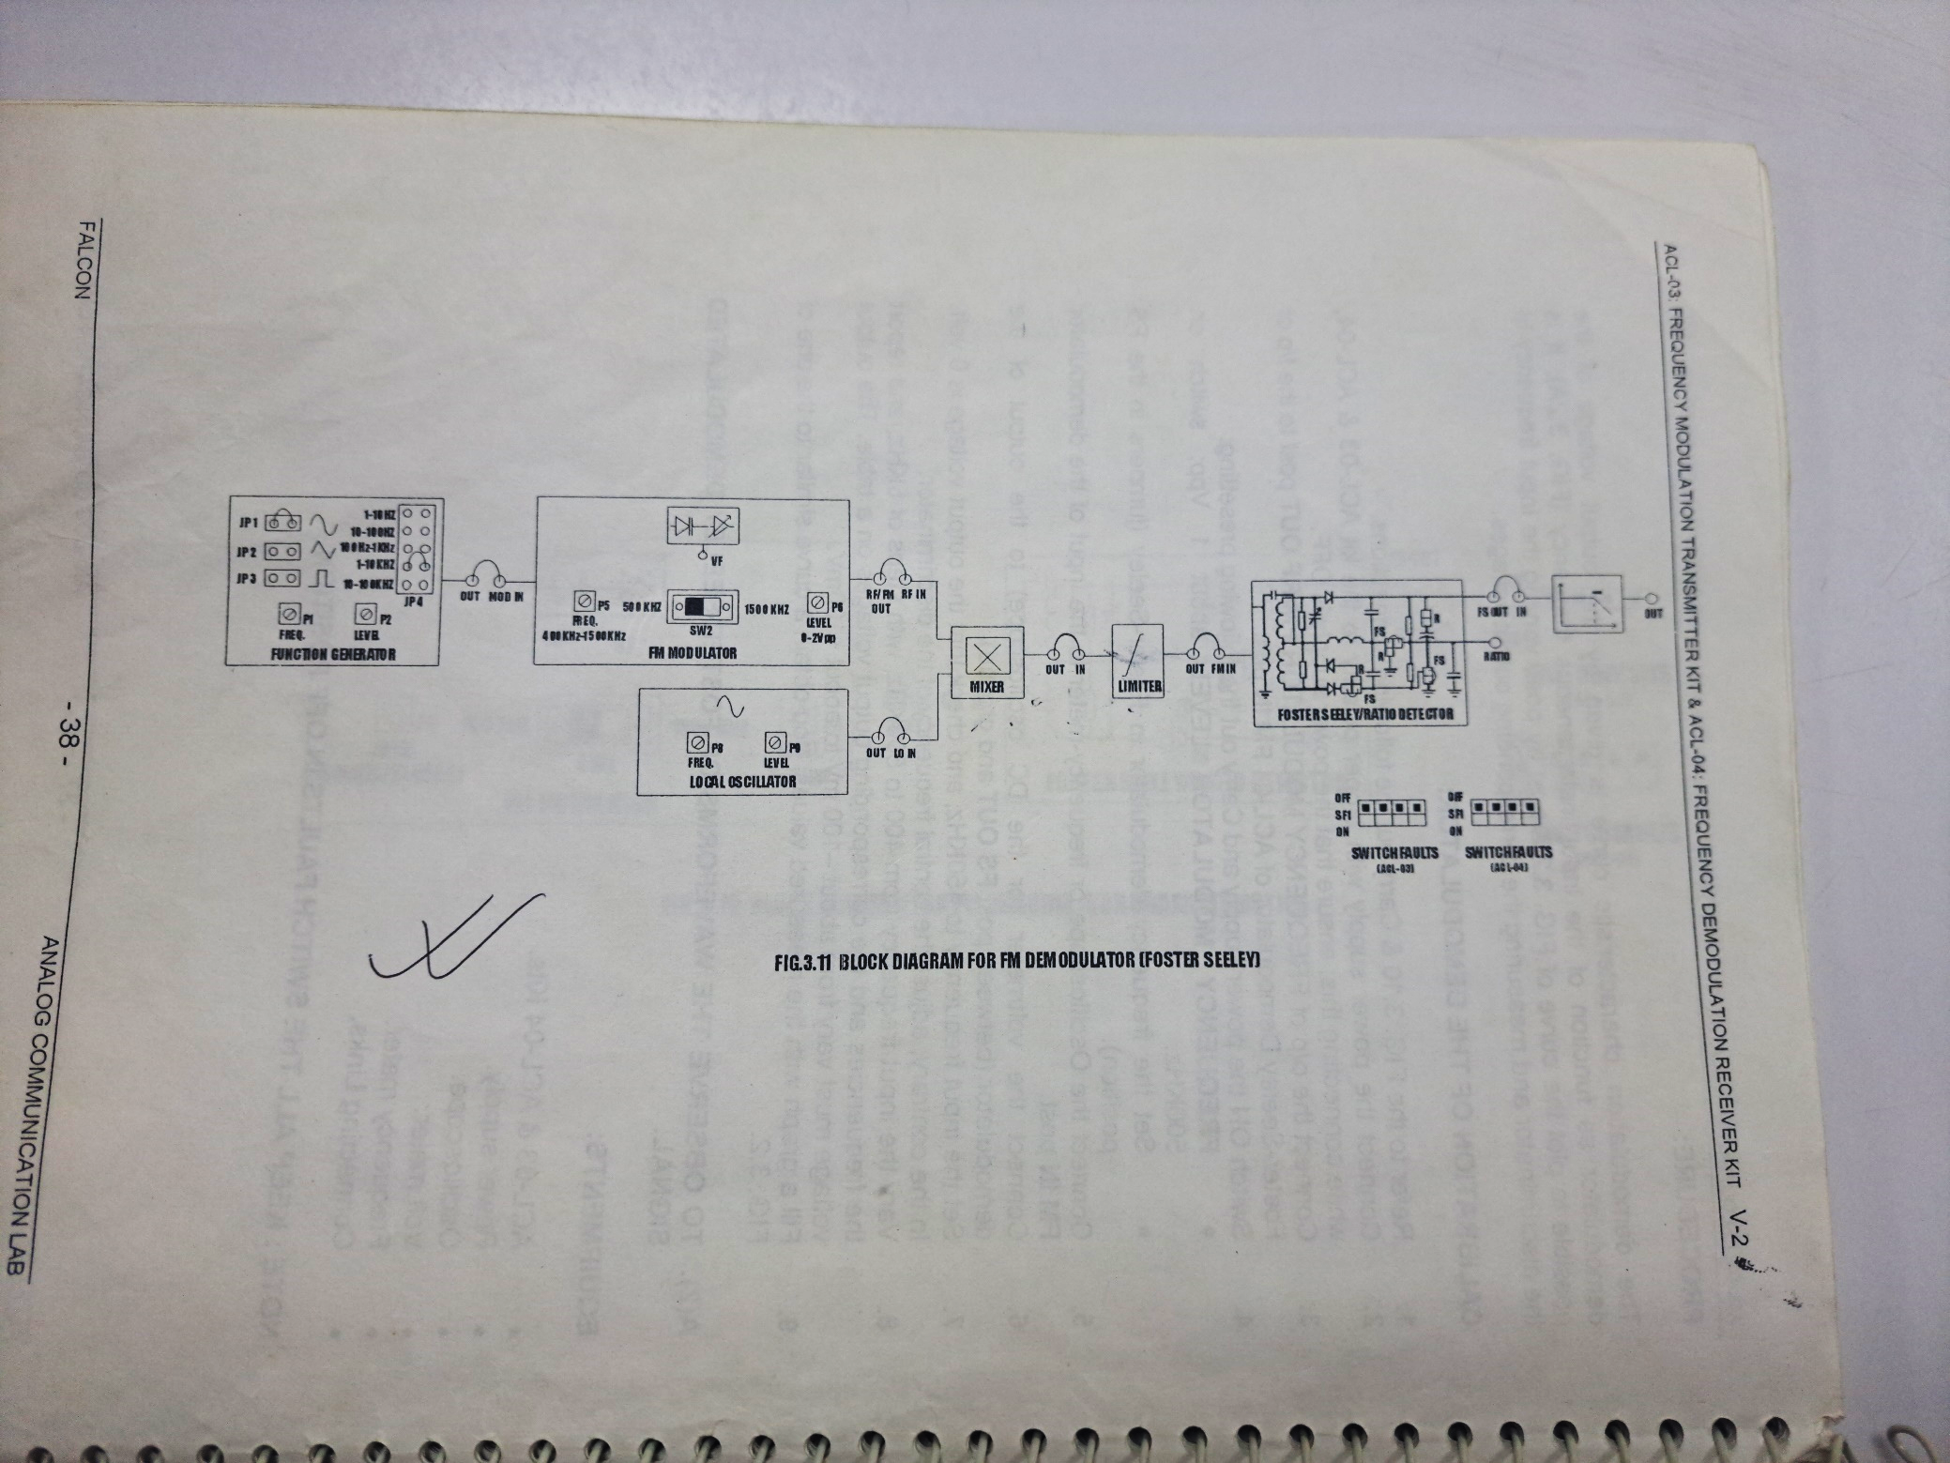

Fig.03.1: Block diagram for frequency demodulation

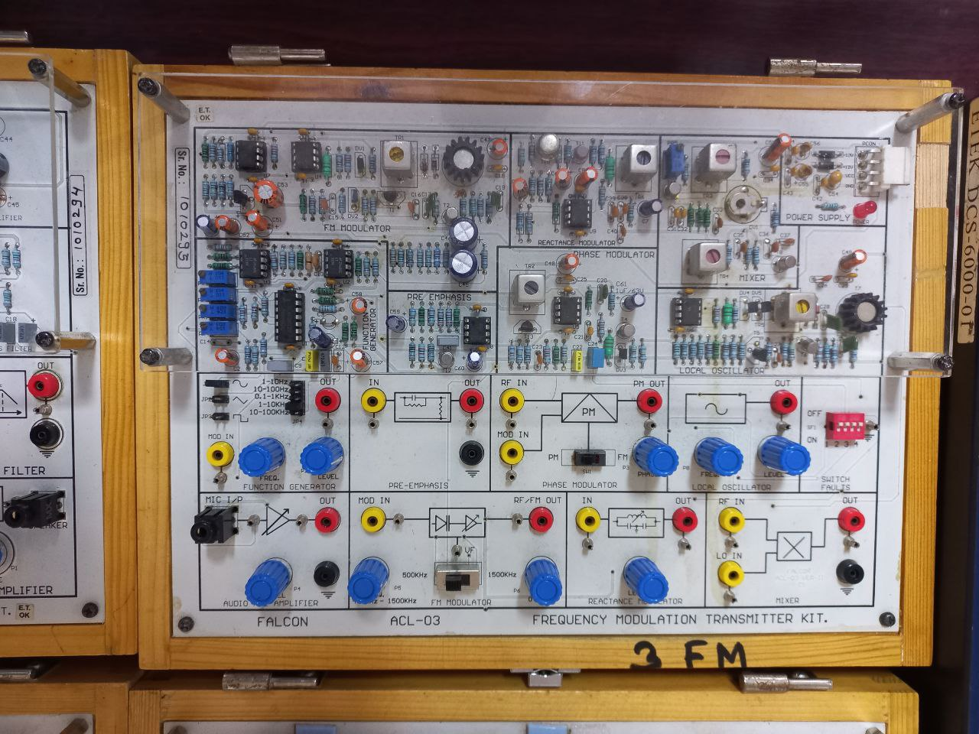 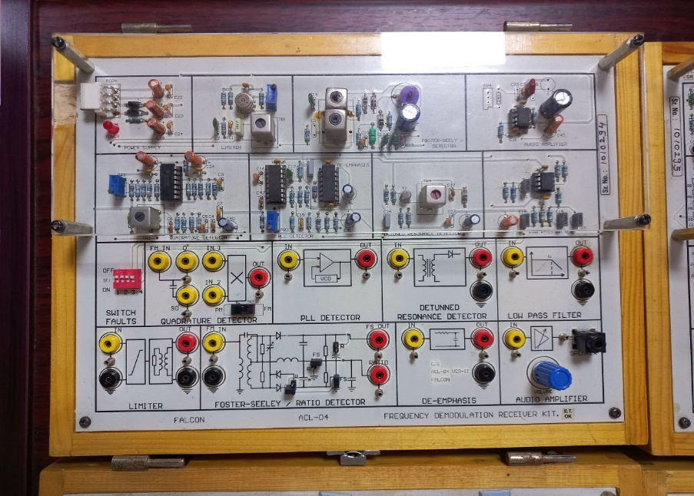

Fig.03.2: Frequency modulation transmitter kit Fig.03.3: Frequency demodulation receiver kit

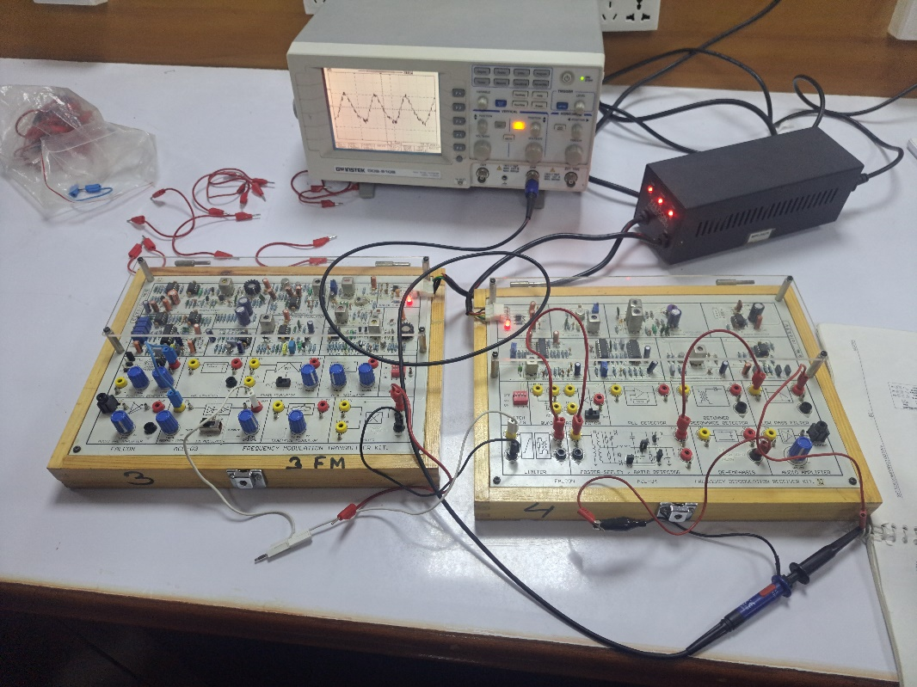

Fig.03.4: Experimental Setup of Frequency modulation and demodulation Experiment

* 1. **Waveforms**

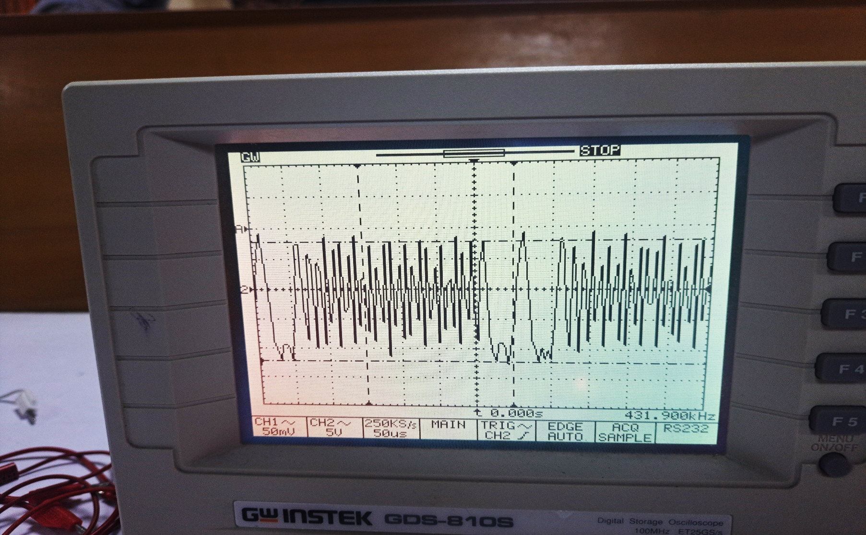

Fig.03.5: Frequency modulated signal

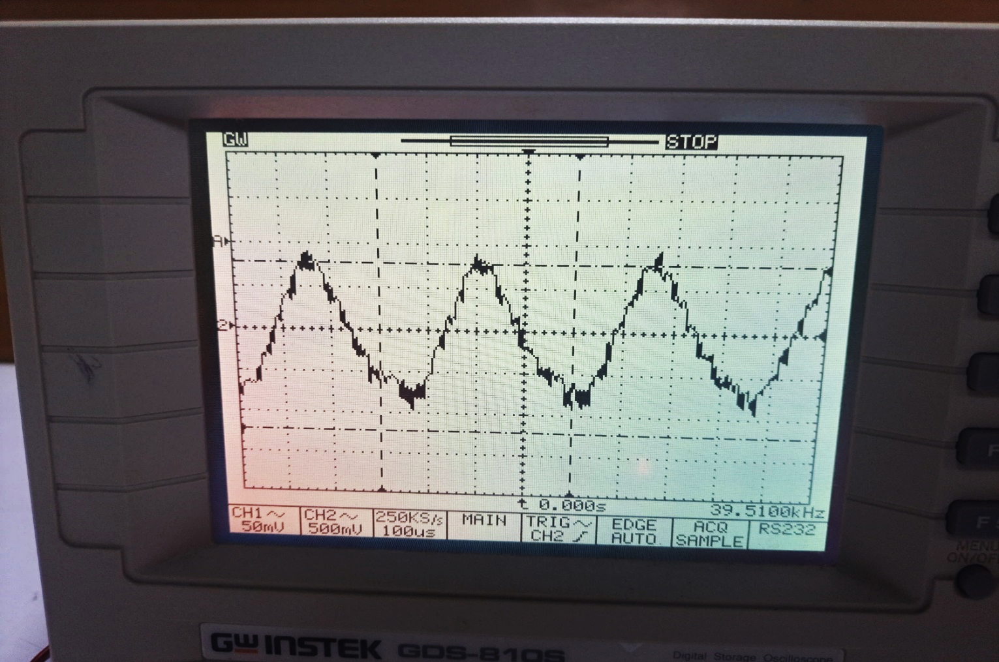

Fig.03.5: Frequency demodulated signal

* 1. **MATLAB code**

clc;%Clears previous data from command window

clear all; %Removes all variables from the current workspace

fs = 1000; %Messege signal frequency

fc = 200; %Carrier signal frequency

t = (0:1/fs:0.2)';

%Create two-tone sinusoidal signal with frequencies 30 and 60 Hz.

x = sin(2*pi*30*t)+2*sin(2*pi*60*t);

%Set the frequency deviation to 50 Hz.

fDev = 50;

%Frequency modulate x.

y = fmmod(x,fc,fs,fDev);

%Demodulate z.

z = fmdemod(y,fc,fs,fDev);

%Plot the original and demodulated signals.

plot(t,y,t,z);

xlabel('Time (s)')

ylabel('Amplitude')

legend('Modulated Signal','Demodulated Signal')

* 1. **MATLAB output waveform**



Fig.03.7: Frequency modulated signal waveform

* 1. **Discussion & Conclusion**

In this experiment, the functions and purposes of frequency modulated signal through laboratory kits were briefly reviewed. Their operation and working principle were also learnt and discussed. It was also possible to compare experimentally obtained modulated signal with MATLAB code generated signal. Because the expected consequence was reached, the experiment was declared successful.

* 1. **Reference**
* Book:

Electronic Communication System- George Kennedy